ESW Notes:

# Paper summaries:

## Harris et al. 2020: Early warning signals of malaria resurgence in Kericho, Kenya

* Processed the raw case data by detrending with a Gaussian kernel (gets rid of temporal autocorrelation)
* Used spaero package to investigate critical slowing down in time series
  + Data for reproducing analysis at: <https://github.com/mjharris95/Kericho-EWS.git>
* Determined the trend in each indicator over time by calculating Kendall’s correlation coefficient, τ, between the calculated rolling window statistic at each time and the time index

## Brett et al. 2018: Anticipating epidemic transitions with imperfect data

* Used pomp package to simulate SIR model
* Used spaero package to calculate the EWS
* Used a modified Gillespie algorithm to simulate demographically stochastic data
* Code to reproduce results at: doi:10.5281/zenodo.1185284

## Bury et al. 2021: Deep learning for early warning signals of tipping points

* They developed an algorithm that provides EWS in 268 empirical and model time series with greater sensitivity and specificity than generic EWS
* Sometimes, a system that’s close to equilibrium may experience slowly changing external conditions that move it toward a tipping point where its qualitative behaviour changes
  + Where “tipping point” is understood as a local bifurcation point
* There exist a limited number of typical bifurcations of steady states, each of which may be described by a “normal form”––a canonical example capturing the dynamical features of the bifurcation
  + In a fold bifurcation, the system exhibits an abrupt transition to a very different state
  + A transcritical bifurcation usually causes a smooth transition, although it can cause an abrupt transition
  + A Hopf bifurcation can lead the system into a state of oscillatory behaviour via a smooth (supercritical) or abrupt (subcritical) transition
* Different bifurcation types correspond to distinct types of dynamical behaviour
  + Other behaviours can emerge near the bifurcation that are common to many normal forms
    - Example: all local bifurcations (there where eigenvalues of the respective matrices cross the imaginary axis) are accompanied by a critical slowing down
    - This is where system dynamics become progressively less resilient to perturbations as the transition approaches, causing dynamics to become more variable and autocorrelated
* Math-wise, critical slowing down occurs when the real part of the dominant eigenvalue (a measure of system resilience) diminishes and passes through 0 at the bifurcation point
* Generic EWS are intended to work across a range of different systems by detecting critical slowing down, but these indicators do not tell us which type of bifurcation to expect
* SO, this paper *allegedly* developed an algorithm that will make clear the type of transition (ex. Sudden or gradual) the system will undergo/provide information about the new state of the system (ex. Stable or oscillatory)
* They test the DL algorithm on data from systems that showed a critical slowing down before a local bifurcation; EWS of global bifurcations are much more difficult to detect
  + Examples of local bifurcations include: Saddle-node (fold); transcritical; pitchfork; period-doubling (flip); Hopf)
* EWS require high resolution data from a long time series leading up to the tipping point

## Dakos et al. 2008: Slowing down as an early warning signal for abrupt climate change

* Were abrupt climatic changes a result of Earth’s system reaching a critical tipping point?
* They look at 8 abrupt climate shifts and find that they were all preceded by a characteristic slowing down of the fluctuations starting well before the actual shift
  + Such slowing down, measured as increased autocorrelation, can be shown as a hallmark of tipping points

## O’Regan and Drake 2013: Theory of early warning signals of disease emergence and leading indicators of elimination

* This paper considers SIS and SIR models that are slowly forced through a critical transition
* Elimination and emergence of ID involve a transmission system that’s pushed over a critical point
  + Criticality occurs when the basic reproductive number is equal to one
  + Similar critical points occur in other complex systems
* Particularly, in noisy systems, these critical points manifest as transitions between alternative modes of fluctuation
* We call such a stochastic transition a critical transition if there exists a bifurcation in a suitably constructed limit base of the mean field model
* A central problem in the study of critical transition is the identification of phenomena indicating the proximity to a critical transition in the absence of a detailed understanding of the system’s dynamical equations and/or the forcing variables causing the change
  + Recent studies have established that some noise-induced phenomena may signal the approach to a critical transition in a slowly forced dynamical system
  + If true, we could forecast ID emergence in subcritical systems, without models (just looking at data)
  + Many of these characteristic noise-induced phenomena involve critical slowing down, a decline in the resilience of the system to perturbations, which generally gives rise to an increase in the variance and autocorrelation of fluctuations as the system approaches the transition
  + Observing critical slowing down requires that the potential function of the system, if it exists, be smooth
* It’s especially difficult to anticipate critical transitions in ID systems for a number of reasons:
  + ID systems are complicated by amplification of transients and oscillatory dynamics
  + IDs are often seasonally forced
  + … and propagate in demographically open systems subject to imported cases
  + Diseases that are close to elimination/emergence are characterized by low prevalence, and are therefore subject to DS and are difficult to observe
* Leading indicators for SIR systems approaching elimination aren’t always consistent with the standard expectations of increasing variance, increasing autocorrelation, and increasing coefficient of variation (see pgs. 9-16 (or, 341-348)) of this paper for more detail)

## Dibble et al. 2016: Waiting time to infectious disease emergence

# Let’s talk about Gaussian kernels!

* Gaussian kernels (also known as Gaussian filters) are used to de-trend data, and in our case, remove temporal autocorrelation
  + Where temporal autocorrelation refers to the relationship between successive values (i.e. lags) of the same variable
  + Results in observations taken closely together in time being correlated, leading to non-random residuals
* Generally, a kernel is a way of placing a data space into a higher dimensional vector space so that the intersections of the data space with hyperplanes in the higher dimensional space determine more complicated, curved decision boundaries in the data space
* The “kernel”, when used for smoothing, defines the shape of the function that is used to take the average of the neighbouring points; a Gaussian kernel is a kernel with the shape of a Gaussian curve
* The Gaussian smoothing operator is used **to `blur' images and remove detail and noise**.
  + Similar to the mean filter, but uses a different kernel that represents the shape of a Gaussian hump
* <https://shapeofdata.wordpress.com/2013/07/23/gaussian-kernels/>
* <https://towardsdatascience.com/gaussian-process-kernels-96bafb4dd63e>
* <https://matthew-brett.github.io/teaching/smoothing_intro.html>
* <https://pages.stat.wisc.edu/~mchung/teaching/MIA/reading/diffusion.gaussian.kernel.pdf.pdf>
* <https://stats.stackexchange.com/questions/582884/detrending-with-a-gaussian-kernel>
* An R package for this: <https://cran.r-project.org/web/packages/KRLS/KRLS.pdf>
* On the Bury et al. 2021 paper: <https://fabiandablander.com/Deep-Warning.html>

# Detrending

## Harris et al. 2020

* “To better distinguish the signal of critical slowing down from background noise and periodic trends, we preprocessed the raw case data by detrending with a Gaussian kernel.”

## Delecroix et al. 2022 (medrxiv)

* “Another common characteristic of infectious diseases reflected in epidemiological data is seasonality. Miller et. simulated time series of infectious diseases subject to seasonal patterns by varying the transmission rate periodically with different levels of amplitude. They found that seasonality does not highly affect the of the indicators, as for time series with the highest amplitude of seasonal transmission the performance decreased by 0.02 to 0.07 compared to a sensitivity of 0.85 for non-seasonal simulations. Seasonal detrending did not significantly improve the performance, especially in datasets with low amounts of seasonal fluctuations (21). Dessavre et al. found that detrending can help improve the accuracy of prediction for some indicators in the case of disease elimination in multiple subpopulations for instance, an argument supported by O'Dea et al. (16, 37).”
* “Once we know the disease transition is relevant with regard to resilience indicators, pre-processing of the data should be conducted prior to the analysis. Detrending of the data series is usually necessary to avoid spurious trends in the indicators due to slow changes in the mean (17). This is essential, especially for seasonal data. Seasonality affects the spread of a number of diseases, creating periodic fluctuations in the data. These fluctuations have an effect both on variance and autocorrelation, introducing misleading results. When studying a disease subject to periodicity, the number of data points should be much higher than the period. In other terms, if the disease has waves every winter, one should have data over several years. This helps assess if the trend in the indicators is truly due to long-term re-emergence and not to seasonal fluctuations.”
* “It is good practice to check the effect of the window size and detrending in a sensitivity analysis (17).”

## Bury et al. 2021

* “The simulation output time series from the random dynamical systems were detrended using Lowess smoothing with a span of 0.2 to obtain the residual time series that formed the training set.”
* “Data are detrended using Lowess smoothing with a span of 0.2 and degree 1. EWS are computed from residuals using a rolling window of 0.5.”
* “We use the same data preprocessing as Dakos et al. (17), which involves using linear interpolation to make the data equidistant, and detrend with a Gaussian kernel smoothing function. Bandwidth of the kernel is specified for each time series (17) to remove long-term trends while not overfitting. For each time series, we generate 10 null time series of the same length from an AR (1) process fit to the initial 20% of the residuals, yielding a total of 70 null time series and 7 forced time series.”

## Dablander et al. 2022

* Detrended the time segment of interest using the R package, *spaero*
* Rolling window size for detrending and EWS can differ; here they looked at windows of size δ1 ∈ [2, 4, …, 18, 20] for detrending (estimating the mean) and rolling windows of size δ2 ∈ [5, 6, …, 30] for indicator estimation (with the mean being the exception)
* “… backwards rolling windows with a uniform kernel were used for detrending and non-parametric estimation of the mean, variance, coefficient of variation, index of dispersion, skewness, kurtosis, autocovariance, autocorrelation, decay time and first differences in variance. We used rolling windows a 10th the size of the duration for which Rt stays constant; that is, for t1 ∈ [25, 50, 100, 200] we used rolling windows of sizes δ1 = [3, 5, 10, 20], respectively. For indicator estimation, we used rolling window sizes of δ2 = 25 (except for the mean), using the R package *spaero*.”

## Southall et al. 2021

* “The calculation of EWSs from real-world data requires suitable pre-processing, such as the detrending of the data to remove the mean (steady state) and obtain the fluctuations.”
* “In simulation studies, this process can be done by removing the average over replicate realizations, and it has been shown that stochastic simulations produced using the Gillespie algorithm match the theoretical predictions of EWSs [25,27,31,35].
* In practice, without the availability of true replicates, Gaussian detrending is often implemented. Gaussian detrending is a moving average technique, which removes a weighted mean over a selected window size, where the weights are taken from a Gaussian kernel with a user-inputted standard deviation.
  + This method not only requires the user to select a suitable choice of window size and standard deviation, but also makes the assumption that the data are ergodic. This raises a key challenge with this technique, as ergodicity only holds for stationary time series; however, these methods will be implemented on data that are believed to be approaching a critical transition. For this reason, the choice of the window size and the speed a disease is approaching a critical transition are interlinked when deciding if the assumptions of Gaussian detrending are appropriate. In particular, O’Regan & Drake [21] discussed the limitations of Gaussian detrending for diseases that decline rapidly, finding that, even for slowly changing diseases, smaller window sizes did not capture the fluctuations and larger window sizes did not successfully remove the slowly varying trend. Even with its recognized limitations, Gaussian detrending is a popular method in the EWS literature for disease transitions [21,22,33,40].
  + Recent work has begun to develop a specific detrending method for epidemiological data. Dessavre et al. [27] present a spatial detrending approach, which removes the mean over multiple populations to obtain the fluctuations. Unlike Gaussian detrending, this approach does not require any hyperparamaters to be inputted; however, it does assume spatial ergodicity, i.e. all subpopulations are similar. The use of spatial data to overcome some limitations in detrending is promising, particularly for fine-scale spatial data, such as within a county or state where the spatial ergodicity assumption is suitable. Furthermore, O’Dea & Drake [25] found that statistics calculated over multiple heterogeneous realisations, where the parameter set for each realization was sampled randomly, corresponded well with the analytical results. This simulated study could be thought of as calculating EWSs between many non-identical locations, supporting evidence of spatial detrending.
  + In addition, there is the added challenge of removing periodic trends in the time series to obtain the residuals. Many infectious diseases exhibit seasonal forcing due to climate and human behaviour, which may dominate the behaviour of EWSs close to the critical transition. However, Miller et al. [33] found that it was not necessary to seasonally detrend the time series first, noting that autocorrelation performed worse with seasonal decomposition than Gaussian detrending. It was shown that variance was insensitive to the type of detrending (Gaussian, seasonally decomposition or differencing), although the performance worsened with all detrending methods when the data had high levels of periodic forcing.

**Figure 3.** Time-series trends of EWSs. EWSs calculated on monthly pertussis incidence data. (a,c,e,g) show trends for Vermont (highest incidence burden between 1992 and 2007). (b,d,f,h) show trends for Mississippi (lowest incidence burden between 1992 and 2007). EWSs calculated using spatial detrending are shown by solid lines, and with Gaussian detrending by dashed lines (window size 10% of time-series length (window size = 70), standard deviation of Gaussian filter calculated using Silverman’s rule of thumb (s.d. = 4.55, mean over states)). EWSs were calculated on detrended time series using moving averages (right window) with window size 10% of time series, data prior to 1991 was cut off after calculations. Inset shows Kendall’s τ score for each EWS on varying amounts of data up to 2007. Kendall’s τ at time point t is calculated over the window EWS ∈ [t, 2007]. (a) Incidence (Vermont). (b) Incidence (Mississippi). (c) Variance (Vermont). (d) Variance (Mississippi). (e) Coefficient of variation (Vermont). (f) Coefficient of variation (Mississippi). (g) Autocorrelation lag-1 (Vermont). (h) Autocorrelation lag-1 (Mississippi).

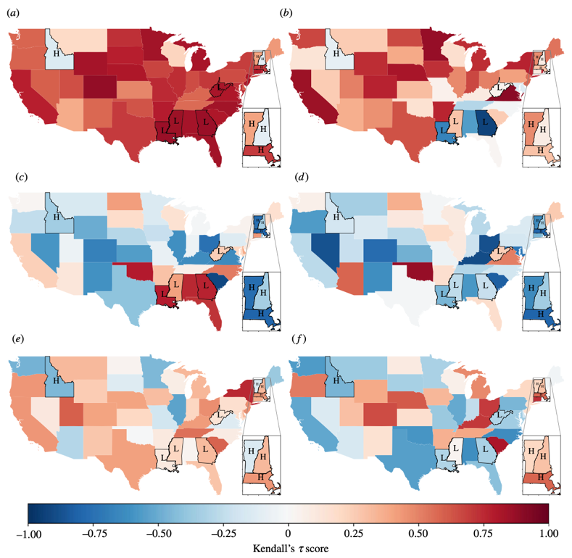

**Figure 4.** Kendall’s τ score for variance, coefficient of variation (CoV) and autocorrelation lag-1 (AC(1)). Kendall’s τ score calculated on EWSs for each state between 1992 and 2007. A score near 1 indicates an increasing trend in the EWS, while a score near −1 indicates a decreasing trend. (a,c,e) show EWSs calculated on spatialdetrending data; (b,d,f) show EWSs calculated on Gaussian-detrending data as described in electronic supplementary material, figure S2. States labelled ‘H’ indicate the four states of highest incidence (Vermont, Massachusetts, New Hampshire, Idaho); states labelled ‘L’ indicate the four states with lowest incidence during this period (Mississippi, Louisiana, West Virginia, Georgia). (a) Variance (spatial detrending). (b) Variance (Gaussian detrending). (c) CoV (spatial detrending). (d) CoV (Gaussian detrending). (e) AC(1) (spatial detrending). (f) AC(1) (Gaussian detrending).

* Figure 3c,e,g shows that the EWSs and Kendall’s τ results were largely consistent across detrending types for regions of a very high burden of incidence (also shown in figure 4; states labelled ‘H’), while in regions of low incidence (figure 3d,f ,h and figure 4 labelled ‘L’) the results are contrasting between spatial and Gaussian detrending. Notably, the time evolution of variance in Mississippi (figure 3d) visually increases for Gaussian and spatial detrending; for spatial detrending this corresponds with a Kendall’s τ score ≥0.75, signifying the increasing trend, but for Gaussian detrending over the same time period the score ≈0.25 (e.g. constant trend). The overall agreement between spatial and Guassian detrending for each state is shown in electronic supplementary material, figure S5. In particular, we find that variance is the most sensitive to detrending type, and autocorrelation lag-1 the least. Spatial detrending was conducted over all states in continental USA (i.e. excluding Alaska and Hawaii), although we stress that, owing to the geographical unevenness of pertussis, this does not satisfy the spatial ergodicity condition. Further work is needed to test a selective-spatial detrending approach, where US states of similar pertussis or vaccination rates are detrended together.
* The inset figures (figure 3) investigate the sensitivity of Kendall’s τ score with respect to the time frame used. In figure 3c, Kendall’s τ score changes from weakly increasing over the whole time series of variance to weakly decreasing when just including the previous 4 years, reflecting the increasing behaviour of variance from 1995 to 2003, before it falls. This could lead to misleading conclusions if the interval to calculate Kendall’s τ score is not chosen carefully.
* For the high-risk burden state, Vermont, Kendall’s τ score is insensitive to data aggregation for variance and coefficient of variation, and insensitive to the detrending method for all three statistics considered (electronic supplementary material, figure S3). However, the window size of the moving average impacts the Kendall’s τ score, so that for window sizes between 15% and 55% of the time-series length the variance increases (Kendall’s τ score near 1), while for window sizes greater than 55% variance strongly decreases (Kendall’s τ score near −1). The choice of window size has been investigated by Lenton et al. [14] as well as by Kaur et al. [40] in their study on EWSs of COVID-19 emergence, finding that large window sizes altered the results. In summary for Vermont, variance is strongly increasing for most choices of window sizes and aggregation, coefficient of variation is weakly decreasing, and autocorrelation lag-1 has a mixed response which perhaps can be explained by the stochastic nature of pertussis in Vermont; the former two indicate characteristics of disease emergence from CSD.
* By contrast, all EWSs are sensitive to detrending for Mississippi, and detrending can influence whether the observed trend is increasing or decreasing. However, variance and coefficient of variation are insensitive to time aggregation, and results are consistent when the window size is between 15% and 55%. No conclusions on the status of pertussis in Mississippi can be drawn from this analysis, with spatial detrending suggesting that all EWSs are increasing, perhaps indicating disease elimination (although we would expect variance to decrease prior to elimination [31]). However, results from Gaussian detrending—variance is weakly increasing or flat, coefficient of variation is weakly decreasing or flat and autocorrelation lag-1 is weakly increasing—would suggest that Mississippi is undergoing disease emergence.

## Dessavre et al. 2019

* In order to interpret any potential indicators of elimination, simulations need to be carefully detrended. Detrending is required to remove long-term trends in the data in order to observe critical slowing down in the fluctuations. **Typically, simulations are detrended over multiple realisations of the same process (simulation detrending, see Fig. 1(a))**, however this is not applicable with real-world data. **To calculate statistics from real data, in the EWS literature windowed detrending is usually used, where the moving window average is removed from the timeseries (windowed detrending, see Fig. 1(a))**.
* Having detrended the data we may calculate each statistic in two ways: either using multiple simulations and finding the variance, say, between the realisations; or taking moving windowed statistics, assuming that the system is changing slowly enough to be approximately ergodic, so that the time-averaged statistic approximates the desired value. When considering real data we would take a moving windowed approach for both detrending and calculating the statistic. Thus there are essentially three approximations that are being made to the system: the linear noise approximation assumes gaussian noise and approximates integer numbers of infections by a continuous variable; the detrending of the signal; and the calculation of the moving window statistics.
* Other detrending methods can also be considered before calculating potential indicators of elimination for a single population. For all detrending methods that were considered, the resulting CV remained more similar than the variance, supporting our result that the CV is more robust to detrending methods than the variance. Other methods considered (Figures not shown here) are given below:
  + Gaussian detrending: the timeseries is smoothed by windowed average with gaussian weighting, so that data close to the timepoint considered are weighted more highly than those further away. For smaller windows this is very similar to the windowed mean detrending whereas for larger windows spurious oscillations became apparent, particularly close to disease extinction. This method has been used successfully to detrend historical climate records to indicate abrupt climate change shifts (Dakos et al., 2008) and further work has been carried out analysing the sensitivity of the bandwidth used for filtering (Lenton et al., 2012).
  + Windowed linear regression: linear regression is undertaken on each moving window. This gives similar results to Gaussian detrending, with undesirable excursions away from the prediction, even for moderately sized windows (Lenton et al., 2012).
  + Windowed quadratic regression: quadratic regression is undertaken on each moving window. This has not been considered in the critical slowing literature, and gives good results at smaller window sizes, getting progressively closer to the predictions for larger windows, however, spurious results still dominate for larger windows before reaching the predicted levels.
  + Wavelets: wavelets are used to fit the timeseries before discarding higher order wavelets to smooth the signal. This is a large class of methods, corresponding to different wavelets with different levels of smoothing and, in principle, may represent an as-yet under-explored class of techniques for critical slowing down (Dakos et al., 2012). In particular it may be possible to design specific wavelets with this application in mind. However, using more classical wavelets, such as the Daubechies extremal-phase wavelets or symlets, it is very difficult to get robust results close to the predictions, and instead we obtain very noisy signals with a lot of spurious oscillations.

**Figure 1.** (a) Methods for detrending implemented for the SIS model. Left: detrending by calculating the mean over a window for one realisation (Windowed Detrending, as seen in Fig. 2 (b)). Right: detrending calculated over a subset of multiple realisations (simulation detrending, as seen in Fig. 2 (c) and (d)). (b) Methods for detrending and calculating the variance over M2 subpopulations, each with population size of NM = N/M2. This was implemented in Fig. 3. Each method was calculated over multiple realisations to assess the mean behaviour.

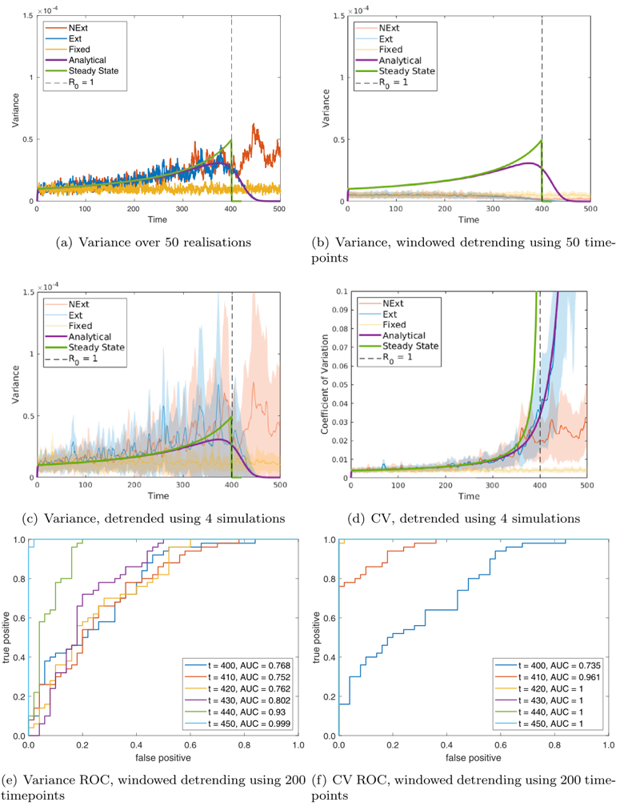

**Figure 2.** Single population: comparing predictions to simulations for variance: (a) over 50 realisations; (b) over a moving window of size 50 timepoints; and (c) over a moving window of size 50 timepoints, first detrending using the mean of 4 simulations and (d) of the CV calculated over a moving window of size 50 timepoints, first detrending using the mean of 4 simulations. ROC curves are calculated over 50 realisations at various timepoints by thresholding in (e) variance; and (f) CV using windowed detrending. For each ROC curve the legend gives the area under the curve (AUC), suggesting how predictive that indicator is (AUC closer to 1 are more predictive). Each figure shows: steady state predictions (green line); dynamic predictions (purple line); simulations of the model going extinct (Ext, blue line); simulations of the model not going extinct (NExt, red line); and simulations of the model with fixed β (FBeta, yellow line). For repeated simulations each line is the mean value obtained over 50 simulations and the shaded area represents one standard deviation about the mean.

**Figure 3.** Metapopulation: comparing predictions to simulations for variance: (a) for M = 2, over 50 realisations; (b) for M = 2, over a moving window after detrending using the mean of the subpopulations; (c) for M = 3, over a moving window after detrending using the mean of the subpopulations, (d) for CV, M = 2, over a moving window after detrending using the mean of the subpopulations; (e) ROC curve calculated over 50 realisations at various timepoints by thresholding in variance, detrending using the mean the subpopulations; and (f) ROC curve calculated over 50 realisations at various timepoints by thresholding in variance, detrending using the mean of 50 realisations. Timeseries figures show: simulation of NExt (red line); simulation of Ext (blue line); dynamic predictions (purple line); steady state predictions (green line). For repeated simulations each line is the mean value obtained over the simulations and the shaded area represents one standard deviation about the mean. Note that for ROC curves no simulation had reached eradication at t=450, although all Ext simulations had achieved eradication by the end of the simulation.

## Dakos et al. 2012

* Gaussian smoothing (autocorrelation, variance, skewness), simple linear detrending (DFA), or by fitting linear autoregressive models (conditional heteroskedasticity). When applying these or any other type of detrending or filtering (i.e. first-differences, removing running means, loess smoothing), care should be taken to not over- fit or filter out the slow dynamics (of interest) from the dataset [8]. Alternatively, one could also detrend within the rolling windows rather than the entire dataset. Lenton et al [27] have shown that results from the two approaches do not significantly differ.

## Miller et al. 2017

* However, prior to reaching criticality, transmission systems may not exhibit a reliably periodic pattern. Thus, it’s possible that periodic detrending or differencing may corrupt the signal of CSD and unintentionally reduce the reliability of the early warning signals.
* For our model, estimating and removing a periodic trend prior to EWS analysis did not improve prediction uniformly among statistics. This was not entirely surprising because the seasonal signal was not apparent in many time series. Rather, sporadically spaced small outbreaks comprised the dynamics. Therefore, periodic detrending and differencing introduced artificial patterns in the time series. In summary, even in systems where transmission is highly seasonal, and a seasonal trend is apparent in a part of the observation window, seasonal detrending is often disadvantageous for forecasting approaches using early warning signals.

## Dakos et al. 2008

* Similarly, good detrending is challenging but critically important, because unfiltered trends may lead to patterns in autocorrelation that are not related to the system’s dynamical response to perturbations we wish to probe.
* Detrending. To filter out long trends and to achieve stationarity we subtracted a Gaussian kernel smoothing function from the data and used the remaining residuals for the estimation of the autoregressive coefficient at lag 1. We chose a bandwidth in such a way that we do not overfit while still removing the long-term trends visible in the records. The same treatment was applied also to the simulated time series and the original records without interpolated points.